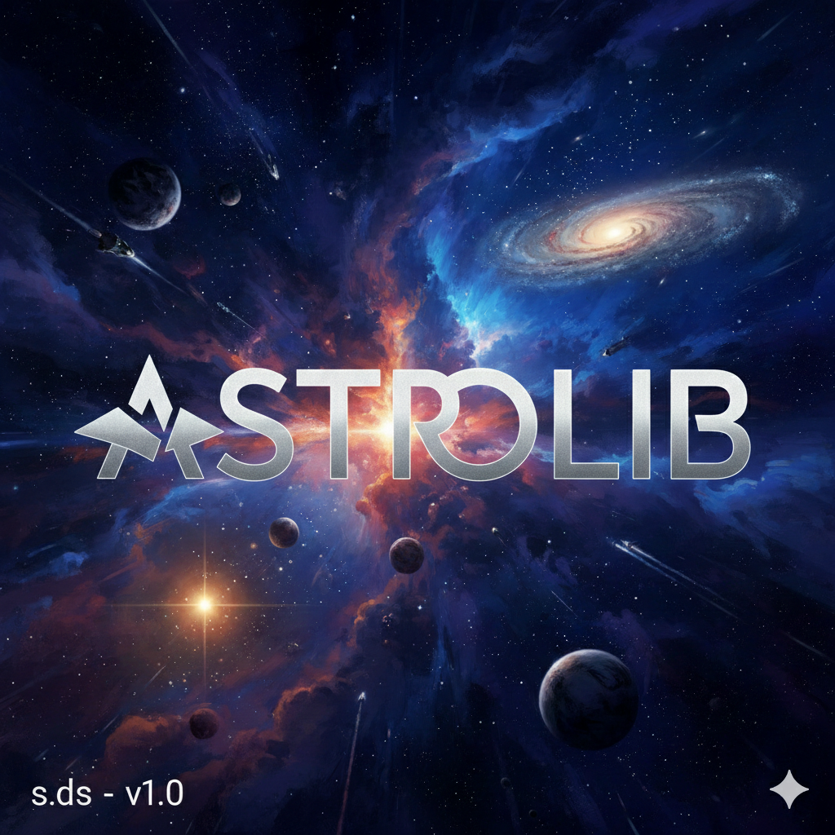

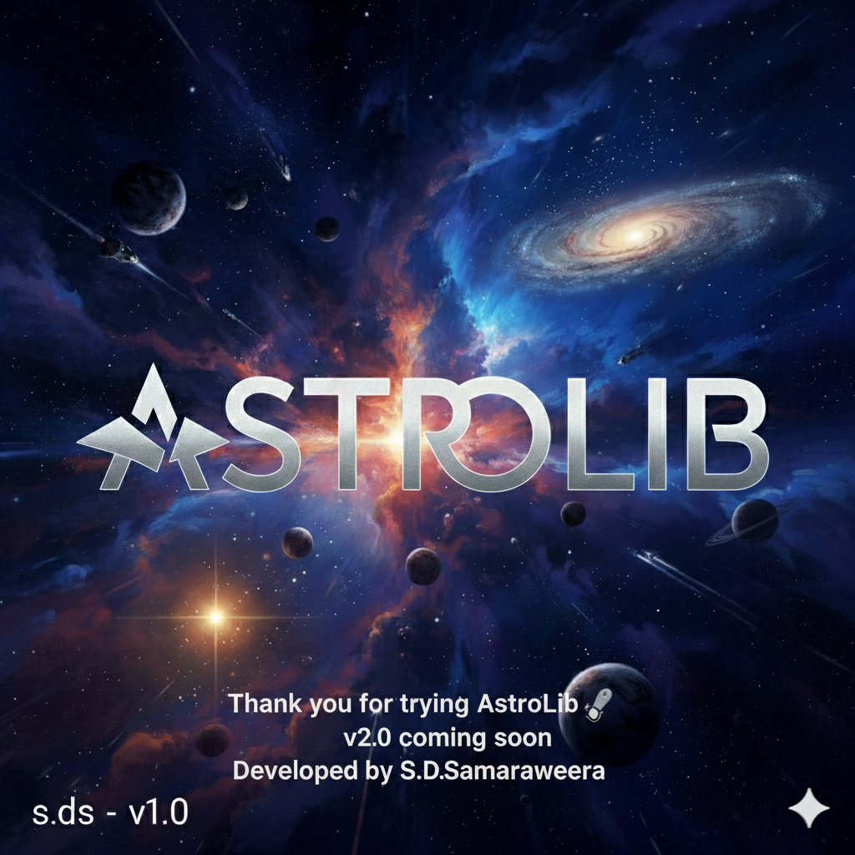

AstroLib

Created by: S.D. Samaraweera
Published: 2026.2
Age of developer: 13
GitHub: (add your link)
License: MIT

What is AstroLib?
AstroLib is a header file for astronomy functions and getting information about the Solar System. It helps you learn planetary physics through C++ coding.
If you have advice or find problems, let me know! I’m still learning, so any feedback is appreciated. 🌌

THINGS TO KNOW
- S.M.A = Semi-Major Axis
- S.MI.A = Semi-Minor Axis
- e = Eccentricity

Functions List
Function | Parameters | Units | Description
GetSemiMajorAxis(time) | 1 | Years | Gets semi-major axis from orbital period
GetOrbitalPeriod(semiMajorAxis) | 1 | AU | Gets orbital period by giving semi-major axis
GetPerihelion(a, e) | 2 | AU | Gets perihelion from semi-major axis and eccentricity
GetAphelion(a, e) | 2 | AU | Gets aphelion from semi-major axis and eccentricity
GetOrbitArea(semiMajor, semiMinor) | 2 | AU² | Gets orbit area
GetEscapeVelocity(radius, mass) | 2 | m/s, kg | Escape velocity of a planet
GetSafeGravity(mass, radius) | 2 | N/kg | Gravitational acceleration (safe with 0 radius)
GetStarBrightness(temperature, coreRadius) | 2 | K, m | Gets brightness of a star
GetStarWavelenght(temperature) | 1 | K | Gets star’s peak wavelength
GetStarIntensity(distance, brightness) | 2 | m, W | Star intensity at a distance
GetStarTemparature(wavelength) | 1 | M | Star temperature from wavelength
GetBlackHolesEventHorizon(mass) | 1 | Kg | Black hole event horizon radius
GetStarReleasingEnergy(mass) | 1 | Kg | Energy released by a star (E=mc²)
GetSemiMinorAxis(semiMajor, e) | 2 | AU | Gets semi-minor axis
GetDistanceFromCenterToAnother(e, semiMajor) | 2 | AU | Distance from orbit center to focus
DetermineTypeOfOrbit(e) | 1 | – | Returns type: Hyperbolic=10, Parabolic=20, Circular=30, Elliptical=40
FindStarsDistance(arcsec) | 1 | arcseconds | Calculates star distance taking parallax angle
FindStarsAll(parsec) | 1 | Parsecs | Takes parsecs and convert them into parallax angle
LightYearToMeters(lightyears) | 1 | Ly | Converts lightyears to meters
LightYearToParsecs(lightyears) | 1 | Ly | Converts lightyears to parsecs

How to Use the Solar System Data Bank
Structure:
Astro::PlanetName::DATA
Example:
double massJupiter = Astro::Jupiter::MASS_KG;
// Output: 1.898e27
Access moons:
double massGanymede = Astro::Jupiter::Ganymede::MASS_KG;
// Output: 1.4819e23

Keywords for Planet Data Bank
Keyword | Description
MASS_KG | Planet mass in kilograms
RADIUS_M | Planet core radius in meters
GRAVITY_MS2 | Surface gravity in m/s²
REVOLVE_S | Orbital period in seconds
ESCAPE_MS | Escape velocity in m/s
TILT_D | Axial tilt in degrees
ROTATION_S | Rotation period in seconds
Notes:
- Moons only have MASS_KG, RADIUS_M, GRAVITY_MS2.
- Dwarf planets have all the same properties as planets.

Planets, Moons, Dwarf Planets Available
Planets & Moons:
- Mercury
- Venus
- Earth → Moon
- Mars → Deimos, Phobos
- Jupiter → Ganymede, Europa
- Saturn → Titan
- Uranus
- Neptune → Triton
Dwarf Planets: Pluto, Eris, Ceres, Makemake, Haumea
Stars: Sun

Cool things that you can do with AstroLib
1.making a machine that take your weight amd make how much you weight in other planets
#include<iostream>
#include "AstroLib.hpp"
int main(){
int weight;
double gEarth = Astro::Earth::GRAVITY_MS2;
std::cout<<"enter your weight kg";
std::cin>>weight;

std::cout<<"mercury" <<weight*(Astro::Mercury::GRAVITY_MS2/ gEarth)<<"Kg\n";
std::cout<<"venus" <<weight*(Astro::Venus::GRAVITY_MS2/ gEarth)<<"Kg\n";
std::cout<<"mars" <<weight*(Astro::Mars::GRAVITY_MS2/ gEarth)<<"Kg\n";
std::cout<<"jupiter "<<weight*(Astro::Jupiter::GRAVITY_MS2/ gEarth)<<"Kg\n";
std::cout<<"saturn "<<weight*(Astro::Saturn::GRAVITY_MS2/ gEarth)<<"Kg\n";
std::cout<<"uranus "<<weight*(Astro::Uranus::GRAVITY_MS2/ gEarth)<<"Kg\n";
std::cout<<"neptune "<<weight*(Astro::Neptune::GRAVITY_MS2/ gEarth)<<"Kg\n";

return 0;
}
//note: you can modifly this by adding dwarf planets moons etc….

2.star cal
#include<iostream>
#include"AstroLib.hpp"
int main(){
double cr;
double t;
double m;
std::cout<<"star funtion calculator\n";
std::cout<<"enter these information\n";
std::cout<<"core radius:\n";
std::cin>>cr;
std::cout<<"enter temparature:\n";
std::cin>>t;
std::cout<<"enter mass";
std::cin>>m;
std::cout<<"brightness"<<Astro::GetStarBrightness(t,cr)<<"W\n";
std::cout<<"wavelenght"<<Astro::GetStarWavelenght(t)<<"\n";
std::cout<<"escapevelocity"<<Astro::GetEscapeVelocity(cr,m)<<"ms2\n";

return 0;
}
AstroLib is great if you interested in astronomy
Please try this and give me feedback to support me
Thank you for trying AstroLib!

There is more you can do with AstroLib few are provided you can use AstroLib + your creativity to make lot of other cool projects if I have time I will post a AstroLib examples book!

